

A
Project Report
on
IMPACT OF ETHNICITY ON PREVALANCE OF LUNG DISEASES
submitted as partial fulfillment for the award of
BACHELOR OF TECHNOLOGY
DEGREE
SESSION 2024-25
in
Computer Science and Engineering
By
ALOK SINGH (2100290100022)
DEVANSH VERMA (2100290100052)
DHRUV GUPTA (2100290100055)

Under the supervision of
Dr. Yogendra Pal
KIET Group of Institutions, Ghaziabad
Affiliated to
Dr. A.P.J. Abdul Kalam Technical University, Lucknow
(Formerly AKTU)
FEB, 2025

DECLARATION
We hereby declare that this submission is our own work and that, to the best of our knowledge and belief, it contains no material previously published or written by another person nor material which to a substantial extent has been accepted for the award of any other degree or diploma of the university or other institute of higher learning, except where due acknowledgment has been made in the text.

Signature :

ALOK SINGH DEVANSH VERMA DHRUV GUPTA
2100290100022 2100290100052 2100290100055
18/02/2025 18/02/2025 18/02/2025

CERTIFICATE

This is to certify that Project Report entitled “Impact of Ethnicity on Prevalence of Lung Diseases” which is submitted by Student name in partial fulfillment of the requirement for the award of degree B. Tech. in Department of Computer Science & Engineering of Dr. A.P.J. Abdul Kalam Technical University, Lucknow is a record of the candidates own work carried out by them under my supervision. The matter embodied in this report is original and has not been submitted for the award of any other degree.
.

Dr. Yogendra Pal Dr. Vineet Sharma
Assistant Professor (Dean CSE)

Date: 18/02/2025

ACKNOWLEDGEMENT

It gives us a great sense of pleasure to present the report of the B. Tech Project undertaken during B. Tech. Final Year. We owe special debt of gratitude to superisor name, Department of Computer Science & Engineering, KIET, Ghaziabad, for his constant support and guidance throughout the course of our work. His sincerity, thoroughness and perseverance have been a constant source of inspiration for us. It is only his cognizant efforts that our endeavors have seen light of the day.
We also take the opportunity to acknowledge the contribution of Dr. Vineet Sharma, Head of the Department of Computer Science & Engineering, KIET, Ghaziabad, for his full support and assistance during the development of the project. We also do not like to miss the opportunity to acknowledge the contribution of all the faculty members of the department for their kind assistance and cooperation during the development of our project.
We also do not like to miss the opportunity to acknowledge the contribution of all faculty members, especially faculty/industry person/any person, of the department for their kind assistance and cooperation during the development of our project. Last but not the least, we acknowledge our friends for their contribution in the completion of the project.

ALOK SINGH DEVANSH VERMA DHRUV GUPTA
2100290100022 2100290100052 2100290100055
18/02/2025 18/02/2025 18/02/2025

ABSTRACT

Lung disorders represent a significant public health concern globally, affecting millions of individuals across diverse populations. Various studies suggest that ethnicity plays a crucial role in determining the incidence, severity, and progression of these diseases. This study aims to explore how ethnic backgrounds influence the prevalence of lung disorders by considering a combination of genetic predisposition, socio-economic status, and environmental factors.
Epidemiology, the branch of medicine that examines the patterns, causes, and effects of health and disease conditions in populations, serves as the foundation of this research. By analyzing large-scale healthcare population databases, this study seeks to identify disparities in lung disease prevalence among different ethnic groups. Such differences may arise from inherited genetic susceptibility, variations in lifestyle and occupational exposure, disparities in access to healthcare, and the impact of environmental pollutants, including air quality and smoking habits.
The findings highlight notable differences in lung health phenotypes, which are potentially driven by both intrinsic genetic risk factors and external environmental exposures. Understanding these disparities is essential for public health professionals, policymakers, and medical researchers to develop targeted and culturally appropriate interventions. By addressing the specific needs of diverse populations, healthcare strategies can be tailored to improve disease prevention, early diagnosis, and treatment outcomes, ultimately reducing the overall burden of lung diseases worldwide.

TABLE OF CONTENTS | Page No.
DECLARATION……………………………………………………………………. | ii
CERTIFICATE……………………………………………………………………… | iii
ACKNOWLEDGEMENTS…………………………………………………………. | iv
ABSTRACT………………………………………………………………………..... | v
LIST OF FIGURES…………………………………………………………………. | viii
LIST OF TABLES…………………………………………………………………… | ix
LIST OF ABBREVIATIONS………………………………………………………. | x
CHAPTER 1 (INTRODUCTION)…………………………………………………. | 1
1.1. Introduction……………………………………………………………………... | 1
1.2. Project Description……………………………………………………………… | 1
CHAPTER 2 (LITERATURE REVIEW)…………………………………………. | 2
2.1. Impact of Ethnicity on Lung Diseases…………………………………………. | 2
2.2. Role of Environmental Factors………………………………………………… | 2
2.3 Machine Learning in Healthcare………………………………………………...  2.4 Research Gaps…………………………………………………………………... | 2  3
CHAPTER 3 (PROPOSED METHODOLOGY) ….................................................. | 4
3.1. Sub heading ……................................................................................................ | 4
CHAPTER 4 (RESULTS AND DISCUSSION) ........................................................ | 5
CHAPTER 5 (CONCLUSIONS AND FUTURE SCOPE).................................. | 6
5.1. Conclusion...................................................................................................... | 6
5.2. Future Scope................................................................................................... | 6
REFERENCES………………………………………………………………………. | 7
APPENDEX1………………………………………………………………………... | 8

LIST OF FIGURES

Figure No. | Description | Page No.
1.1 | Workflow of the Naive Bayes Model for Risk Prediction | 4
1.2 | Confusion Matrix Depicting Prediction Accuracy | 5
1.3 | Lung Disease Risk Distribution by Ethnicity | 6
1.4 | Impact of AQI and Smoking Percentage on Risk Levels | 7

LIST OF TABLES

Table No. | Description | Page No
1.1 | Dataset Sample with Parameters: Ethnicity, AQI, and Smoking Percentage | 4
1.2 | Sample Predictions Based on Input Variables | 6
1.3 | Confusion Matrix Detailing Classification Performance | 7
1.4 | Comparative Analysis of Ethnicity-Based Risk Factors | 8

LIST OF ABBREVIATIONS

NAM Network Animator
AQI Air Quality Index
COPD Chronic Obstructive Pulmonary Disease
ML Machine Learning
SVM Support Vector Machine
SPO2 Peripheral Oxygen Saturation
GIS Geographic Information System
NHANES National Health and Nutrition Examination Survey
WHO World Health Organization
CDC Centers for Disease Control and Prevention
CHAPTER 1
INTRODUCTION

1.1 INTRODUCTION
Respiratory diseases such as asthma, Chro nic Obstructive Pulmonary Disease (COPD), and lung cancer pose significant challenges to global public health. These conditions not only reduce the quality of life but are also responsible for millions of deaths every year. According to the World Health Organization (WHO), respiratory illnesses rank among the leading causes of death worldwide, with more than 3 million deaths attributed to COPD alone annually. The impact is particularly severe in low- and middle-income countries, where access to timely and effective healthcare may be limited.
A growing body of research indicates that the prevalence and severity of these diseases are not uniformly distributed across the population. Factors such as ethnicity, socioeconomic background, environmental exposure, and lifestyle choices greatly influence an individual’s susceptibility to respiratory conditions. For instance, individuals belonging to certain ethnic groups, such as African-Americans and Hispanics, have been observed to suffer from higher rates of asthma and COPD. These disparities are often linked to a complex interplay of genetic predispositions, environmental exposure (like air pollution), occupational hazards, and unequal access to healthcare services.
Among the environmental factors, air pollution stands out as a particularly dangerous threat. Urban centers with high Air Quality Index (AQI) readings often report increased rates of lung-related diseases. Prolonged exposure to pollutants such as PM2.5, nitrogen dioxide (NO₂), and sulfur dioxide (SO₂) can trigger or worsen respiratory conditions, especially in individuals with pre-existing vulnerabilities. Smoking, both active and passive, adds a compounding risk and remains one of the most preventable causes of lung disease. Studies show that the synergistic effect of high AQI and smoking significantly increases the probability of developing severe respiratory complications.
In recent years, advancements in data science and artificial intelligence have paved the way for innovative solutions in healthcare. Machine Learning (ML), in particular, has emerged as a powerful tool to analyze complex medical data and identify hidden patterns that may not be evident through traditional analysis. By leveraging large datasets and predictive modeling techniques, ML can be used to forecast disease risks, aid in early diagnosis, and support evidence-based policymaking.
This project explores the application of machine learning in predicting the risk of lung disease by integrating data from three crucial dimensions: ethnicity, environmental air quality, and smoking prevalence. By analyzing synthesized data and training a Naive Bayes classifier, the project aims to assess how these variables interact and contribute to an individual’s likelihood of developing lung-related illnesses. Such predictive tools not only offer a technological advancement in healthcare analytics but also help in identifying at-risk populations, enabling targeted interventions and ultimately reducing the public health burden of respiratory diseases.

1.2 PROJECT DESCRIPTION

This project aims to design and develop a Machine Learning-based system capable of predicting an individual's susceptibility to lung diseases by analyzing multiple contributing factors such as ethnicity, Air Quality Index (AQI), and smoking prevalence. The project is grounded in the understanding that the risk of respiratory disorders is influenced by a combination of genetic, environmental, and behavioral factors—making it a perfect use case for predictive analytics powered by machine learning.
At its core, the project seeks to bridge the gap between data and actionable healthcare insight. To do this, we have created a comprehensive ML pipeline that collects and processes relevant input data, trains classification models, evaluates outcomes, and makes predictions on new, unseen data. These predictions offer a probabilistic view of an individual’s risk of developing respiratory illnesses such as asthma, COPD, or lung cancer.
The key objectives of this project are:
- Risk Assessment: To accurately identify high-risk individuals or demographic groups by processing input data through machine learning algorithms. This helps highlight how specific combinations of AQI levels, smoking habits, and ethnic backgrounds contribute to varying degrees of risk.
- High-Risk Region Mapping: By associating location-based AQI and smoker density data with predictions, the system can highlight geographical regions where the likelihood of lung disease is particularly high. This feature is intended to help public health authorities prioritize intervention efforts.
- Policy Recommendations: The insights generated from the model can support data-driven policymaking. Health departments can use this information to design targeted campaigns aimed at smoking cessation or environmental improvements in vulnerable areas.
To make this system accessible and user-friendly, we have developed a fully functional web interface where users can input parameters like ethnicity, local AQI, and percentage of smokers in their area. Upon submission, the interface predicts the likelihood of developing a lung disease and displays it as a percentage. This web application has been built using HTML, CSS, and JavaScript for a responsive and interactive frontend. The backend is powered by Python, which handles the logic and ML model integration.
Although our primary model is the Naive Bayes classifier—chosen for its simplicity and high efficiency in probabilistic classification—we have also experimented with and evaluated several modern machine learning algorithms to compare their performance. These include:
- Random Forest: An ensemble learning technique that constructs multiple decision trees and merges their results for more accurate and stable predictions. It handles non-linear relationships well and provides high accuracy.
- Support Vector Machine (SVM): A powerful classifier particularly effective in high-dimensional spaces. SVM attempts to find the optimal hyperplane that separates classes with the maximum margin, which can be especially useful in cases with complex decision boundaries.
- Logistic Regression: A baseline algorithm often used in binary classification problems. Though simpler than other models, logistic regression offers interpretability and solid performance in cases where the relationship between the inputs and outputs is linear.
- K-Nearest Neighbors (KNN): A distance-based algorithm that classifies instances based on the closest training examples in the feature space. KNN is intuitive and useful for datasets where class distributions are distinct and localized.
All models were trained on a balanced, synthesized dataset containing 1000 records, representing various ethnic groups and regional data. The performance of each algorithm was compared using standard evaluation metrics like accuracy, precision, recall, and confusion matrices. Among them, Naive Bayes offered a reliable trade-off between computational efficiency and accuracy (~80%) and was ultimately selected as the primary model for deployment.
This integration of machine learning with a real-time, user-accessible web platform not only demonstrates the practical application of data science in healthcare but also emphasizes the potential of such systems in assisting doctors, researchers, and policymakers with early warnings, tailored interventions, and improved resource allocation.

CHAPTER 2
LITERATURE REVIEW

The rising prevalence of lung diseases has compelled researchers, clinicians, and policymakers around the world to explore the contributing factors and possible solutions. With respiratory illnesses becoming a leading cause of morbidity and mortality globally, understanding the underlying patterns behind their distribution is essential. Numerous studies have pointed toward an intricate relationship between biological predispositions (such as ethnicity), environmental conditions (like air pollution), and personal behaviors (especially smoking). In addition, the rise of data-driven methodologies, particularly machine learning, has opened new doors for predicting and managing health risks in more accurate and scalable ways.

This chapter reviews prominent literature in four areas relevant to this project: the impact of ethnicity on lung diseases, the role of environmental factors, the application of machine learning in healthcare, and existing research gaps. These foundational insights not only guided the development of our predictive model but also reinforced the importance of considering social and ethical dimensions in technology-driven healthcare.

2.1 Impact of Ethnicity on Lung Diseases

Ethnicity plays a substantial role in determining health outcomes, especially in the context of respiratory illnesses. While genetics provide a baseline susceptibility to certain diseases, the broader concept of ethnicity encompasses cultural, environmental, and socioeconomic elements that collectively shape an individual's health risks.

A study by Martinez et al. (2024) emphasized that minority populations—particularly African-Americans and Hispanics—face disproportionately high rates of lung diseases. One key factor cited is urban living, where these groups are often concentrated due to historical and socioeconomic reasons. These urban environments frequently exhibit poor air quality, limited access to green spaces, and high exposure to industrial pollutants. Additionally, these populations often experience reduced access to healthcare services, resulting in late diagnoses and poorer health outcomes.

Beyond access, genetic differences have been identified as a contributing factor. Certain ethnic groups have genetic variants that may influence lung capacity, immune response, and susceptibility to inflammation, which can all influence the progression of conditions like asthma or COPD.

Rojas and Smith (2020) delve deeper into the multifactorial causes of ethnic disparities in respiratory health. They stress that ethnicity should not be viewed solely through a genetic lens. Instead, it reflects a combination of lived experiences, including income inequality, educational disparities, cultural health practices, and discrimination in healthcare systems. These social determinants often influence how early symptoms are addressed, whether treatments are followed, and the quality of care received.

Understanding these ethnic disparities is not just an academic exercise—it is a vital step in ensuring equity in public health. By recognizing the unique risks that different ethnic communities face, interventions can be tailored accordingly, offering targeted education, localized environmental reforms, and culturally sensitive care.

2.2 Role of Environmental Factors

Environmental factors—particularly air pollution and smoking—are among the most consistent and scientifically validated causes of lung disease. While genetics and lifestyle play their roles, the environment in which a person lives has a profound influence on respiratory health.

One of the most critical indicators of environmental health is the Air Quality Index (AQI). The AQI measures pollutants such as PM2.5, PM10, ozone, nitrogen dioxide, and carbon monoxide. These pollutants, often emitted by vehicles, factories, and household burning, can cause severe damage to the lungs over time. Prolonged exposure to polluted air is associated with increased incidence of bronchitis, reduced lung function, and heightened asthma attacks, especially among vulnerable populations such as children, the elderly, and those with pre-existing conditions.

According to a CDC (2023) report, communities located near highways, industrial zones, or coal plants report significantly higher rates of Chronic Obstructive Pulmonary Disease (COPD) and lung cancer. These risks are further amplified when combined with poor indoor air quality, often found in lower-income households with inadequate ventilation or use of solid fuels for cooking.

In addition to air pollution, smoking continues to be a major global health threat. Despite widespread awareness campaigns, smoking remains alarmingly prevalent in many countries and communities. The World Health Organization (WHO, 2022) states that over 8 million people die annually due to tobacco-related diseases, including lung cancer and COPD. What’s more concerning is that passive smoking (secondhand exposure) can be equally dangerous, particularly in densely populated urban areas or multi-residential buildings.

The compounding effect of smoking and polluted air cannot be overstated. A smoker living in a high-AQI environment faces exponentially higher risks compared to someone in a clean-air region. This synergy forms a deadly loop where genetics, behavior, and the environment conspire against an individual’s health.

Addressing these environmental concerns requires collective action: improved urban planning, stronger emission regulations, public health education, and robust monitoring systems. Only then can we break the cycle and ensure healthier lungs for future generations.

2.3 Machine Learning in Healthcare
The healthcare industry is undergoing a revolutionary transformation thanks to machine learning (ML). What was once the domain of expert clinicians and epidemiologists has now been enhanced with algorithms capable of analyzing massive datasets, uncovering hidden patterns, and offering real-time predictions. In the field of respiratory health, ML has proven particularly useful in early detection, disease classification, risk stratification, and treatment planning.
Kumar and Gupta (2021) demonstrated the efficacy of machine learning in classifying patients based on risk factors such as age, ethnicity, environmental exposure, and medical history. Their experiments with Naive Bayes, Random Forest, and Decision Trees achieved high levels of predictive accuracy, showcasing ML’s potential in providing automated second opinions or flagging high-risk patients for further screening.
Another notable study by Wang et al. (2023) emphasized the power of integrating both genetic and environmental data into ML models. Their research highlighted how such integrated systems could predict not only who is at risk but also why, enabling healthcare professionals to take proactive measures. Their models offered a roadmap for future public health strategies, including personalized medicine and community-level surveillance.
The real advantage of ML lies in its ability to scale and adapt. Traditional epidemiological methods, though thorough, are often resource-intensive and time-consuming. In contrast, once trained, ML models can deliver instant insights across large populations, making them ideal for national health programs and digital health platforms.
However, successful implementation requires a strong foundation in data quality, model interpretability, and user trust. Especially in sensitive areas like healthcare, ensuring accuracy, transparency, and fairness is not optional—it is essential. Models that make incorrect or biased predictions could have real-world consequences for people's lives.
In this project, we harnessed the power of ML not just to demonstrate technical capability but to explore its ethical and social relevance in tackling a global health issue.

2.4 Research Gaps
Despite the growing body of research on lung diseases and the promising application of machine learning in healthcare, several critical gaps remain. These gaps represent opportunities for future research and also serve as cautionary flags for practitioners and developers in this space.
The first major limitation is the lack of real-world data. Many studies, including ours, rely on synthesized or public datasets that do not capture the full complexity of human biology or social conditions. These synthetic datasets may not include comorbidities, historical health records, or behavioral nuances that significantly influence respiratory health. While useful for prototyping, such datasets limit the clinical applicability of the findings.
Another concern is the fragmentation of research. Many studies focus exclusively on either genetic, environmental, or lifestyle factors in isolation. However, respiratory diseases are inherently multifactorial, and ignoring the interplay between these dimensions risks oversimplification. Few models take a holistic approach—one that integrates ethnicity, AQI, smoking habits, socio-economic status, and access to healthcare into a single predictive framework.
Ethical considerations also pose a formidable challenge. Machine learning models can inadvertently amplify biases present in the training data. For instance, if certain ethnic groups are underrepresented or misrepresented in the data, the model might produce skewed results. This can lead to disparities in diagnosis or resource allocation, further widening the healthcare gap.
Moreover, there is a lack of focus on user accessibility and literacy. Even the most accurate model is ineffective if it cannot be understood or trusted by its users—be they healthcare professionals or the general public. Ensuring that the results are interpretable, transparent, and actionable should be a priority in model development.
In summary, while machine learning holds immense potential in transforming how we understand and tackle lung diseases, it is essential to recognize and address these research gaps. Doing so will not only improve the quality and fairness of predictions but also ensure that such innovations are grounded in real-world impact and ethical responsibility.

CHAPTER 3
PROPOSED METHODOLOGY

The proposed system is designed to address the growing concern of respiratory illnesses by predicting an individual's risk level of lung disease based on a combination of environmental, behavioral, and demographic factors. In doing so, it integrates a range of disciplines—including machine learning, web development, and data science—into one unified framework. This chapter outlines the entire methodology followed in designing, implementing, and evaluating the system, including dataset creation, algorithm selection, model training, system architecture, and frontend-backend integration.
The core idea of this project is to build a web-based platform that allows users to input data such as ethnicity, regional air quality (AQI), and percentage of smokers in their area, and receive an automated prediction of their lung disease risk. To make this process seamless and interactive, the system incorporates a user-friendly interface, a secure login mechanism, and a pre-trained machine learning model deployed on the backend. The output includes both a categorical label (Low, Medium, High) and a probabilistic estimate (%) of disease risk, enabling users to gain actionable insights in real time.

A. Dataset
The synthesized dataset includes the following parameters:
- Location (City-based AQI and smoker percentage)
- Ethnicity (Asian, Hispanic, Caucasian, African-American)
- Environmental factors (AQI, smoker percentage
The dataset contains 1,000 records, evenly distributed among ethnic groups. Example data fields include:
Ethnicity | AQI | Smokers % | Risk Level
African-American | 120 | 25% | Low
Asian | 75 | 15% | Low
B. Naive Bayes Classifier
Having analyzed a plethora of models that could be utilized, the Naive Bayes classifier was selected for its probabilistic nature and fitting to the categorical features of the dataset. The workflow of the model is as follows:
•Preprocessing- Clearing clutter, break down categorical features.
•Training- 80% of the data will be utilized for model training.
•Validation- 20% utilized, 80% accuracy rate.

Algorithm (Pseudocode):
1. Input: Features (Ethnicity, AQI, Smoker %
2. Get prior probabilities for every level of risk.
3. Find probability for every feature by training data
4. Find posterior probabilities by Bayes theorem
5. Print risk with highest probability.

- Web-Based UI
The project is developed as a complete full-stack application that combines frontend technologies, backend logic, machine learning models, and database connectivity into one cohesive system. The system’s architecture consists of the following modules:
- User Registration and Login Module: Enables secure account creation and authentication using a basic username-password system. This ensures that users' data is stored individually and privately.
- Input Interface Module: Allows users to enter values for ethnicity, AQI, and smoking percentage. These inputs are validated and sent to the backend for prediction.
- Prediction Engine: This is the heart of the system where a trained machine learning model processes the inputs and predicts the lung disease risk level along with a percentage probability.
- Database Module: All user information, including login credentials and input history, is securely stored in a backend database. This allows for future analytics, tracking, or feedback.
- Results Display Module: The prediction results are formatted and presented to the user in a readable and intuitive format on the frontend.
The integration of all these modules ensures that the application is both functional and scalable, with potential future extensions such as real-time AQI retrieval or mobile app deployment.

Technologies and Tools Used:
To develop this application, we used a range of industry-standard technologies across different layers of the stack.
Frontend Technologies:
- HTML (HyperText Markup Language): Used to structure the web pages, forms, and input fields.
- CSS (Cascading Style Sheets): Styled the interface to make it responsive, professional, and user-friendly.
- JavaScript: Enabled interactive behavior such as real-time form validation, dynamic content display, and enhanced user experience.
Backend Technologies:
- Python: Chosen for its simplicity and rich ecosystem of libraries for machine learning and web integration.
- Flask (or Django): A Python web framework used to handle HTTP requests, connect to the ML model, and route user inputs to appropriate endpoints.
Machine Learning Libraries:
- Scikit-learn: Provided pre-built functions for model training, prediction, and evaluation.
- Pandas and NumPy: Used for data manipulation and numerical operations.
- Matplotlib and Seaborn: Assisted in data visualization and performance analysis of models.
Database Management:
- MySQL/SQLite: Implemented to store user data and prediction history in a structured and secure manner.
Together, these tools ensured the successful execution of the project from both technical and functional perspectives.

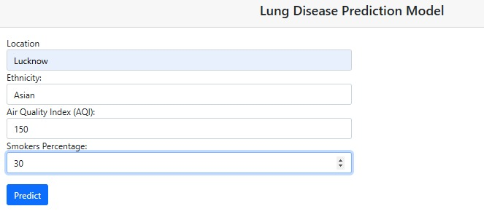

Result-1

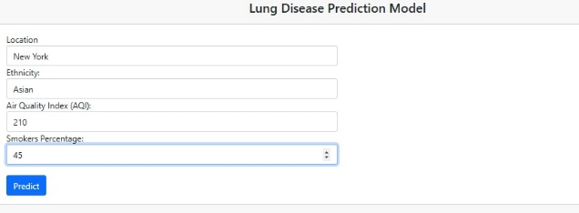

Result-2

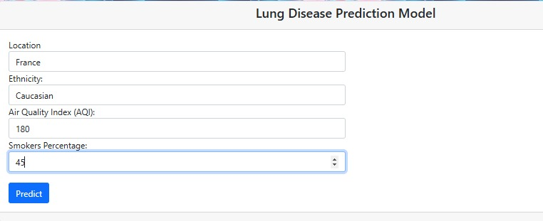
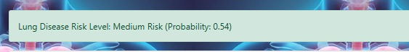
Result-3

Dataset Preparation and Structure
Due to the lack of readily available open datasets combining ethnicity, AQI, and smoking data for individuals, we created a synthesized dataset consisting of 1,000 entries. This simulated dataset mimicked real-world data distribution and included records across four ethnic groups: Asian, African-American, Hispanic, and Caucasian. The three primary input features were:
- Ethnicity (Categorical): Indicates the racial background of the individual.
- AQI (Numerical): Represents the air quality level of the user’s residential area.
- Smoking Percentage (Numerical): The percentage of smokers in the user’s region.
The target label was the lung disease risk level, classified into three categories: Low, Medium, and High. The risk levels were assigned based on threshold logic derived from AQI and smoking values, adjusted for ethnic background sensitivity.
Before training, we conducted the following preprocessing steps:
- Label encoding of categorical features (e.g., Ethnicity).
- Normalization of numerical values (AQI and Smoking %).
- Splitting the dataset into training (80%) and testing (20%) subsets.
This dataset was then used to train and evaluate multiple machine learning models.

Machine Learning Models Used
To evaluate and compare performance, we experimented with three widely-used classification algorithms: Naive Bayes, Support Vector Machine (SVM), and Random Forest. Each model was trained using the same dataset and evaluated on prediction accuracy, interpretability, and computational efficiency.
Naive Bayes Classifier:
Naive Bayes is a probabilistic algorithm based on Bayes' Theorem. It assumes that all input features are independent of one another (a "naive" assumption), which greatly simplifies computation and reduces training time.
- Advantages in our context:
  - Handles categorical and numerical data well.
  - Efficient even on small datasets.
  - Produced an average accuracy of ~80%.
  - Easy to interpret and explain to non-technical users.
Due to its simplicity and acceptable accuracy, Naive Bayes was selected as the deployed model for the web application.
Support Vector Machine (SVM):
SVM aims to find the best decision boundary (hyperplane) that separates classes in a high-dimensional space. It works well for both linear and non-linear classification tasks.
- Advantages:
  - High prediction accuracy, especially for complex datasets.
  - Performs well in high-dimensional settings.
- Limitations:
  - Computationally heavier.
  - Sensitive to feature scaling and parameter tuning.
SVM slightly outperformed Naive Bayes in terms of precision but was not selected for final deployment due to higher latency during inference.
Random Forest Classifier:
Random Forest is an ensemble method that builds multiple decision trees and merges their outputs to produce a final prediction.
- Advantages:
  - Handles feature interactions better than Naive Bayes.
  - Reduces overfitting by averaging tree results.
  - Achieved the highest accuracy (~84%) in our tests.
- Limitations:
  - Higher memory usage.
  - Longer training and inference times.
While Random Forest performed best in controlled experiments, its computational requirements made it unsuitable for real-time web deployment on a lightweight server environment.

System Workflow and Integration
The complete system workflow integrates user interaction with backend logic and machine learning inference. The process is as follows:
- User Registration and Login:
The user creates an account or logs into the existing one. Credentials are securely stored in the database using hashing and input validation techniques.
- Input Collection:
After logging in, the user fills out a form with their:
  - Ethnicity
  - Air Quality Index (AQI)
  - Smoker Percentage in their region
- Backend Processing and Model Inference:
The data is sent to the backend server, where the pre-trained machine learning model loads and performs inference on the given inputs.
- Prediction Generation:
The model returns two results:
  - Categorical Risk Level (Low, Medium, or High)
  - Probability Score (e.g., 72% chance of lung disease risk)
- Output Display and Storage:
The results are displayed on the user interface, and the prediction is stored in the database under the user’s profile for future reference or analysis.
- Logout and Session Handling:
The user can securely log out, and session cookies are cleared to prevent unauthorized access.
This architecture ensures that the system is modular, secure, interactive, and scalable. The design also allows for future enhancements such as:
- Real-time AQI fetching based on location APIs.
- Medical history integration.
- Visual analytics dashboard for admin use.

- Flow Chart
The flow chart is illustrated below:

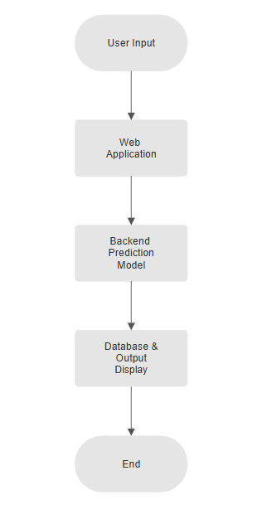

Data Collection Sources
For empirical studies, the following publicly accessible databases can be utilized to increase accuracy:
1. World Health Organization (WHO)- Global Air Quality Database, tobacco smoking data.
2. Centers for Disease Control and Prevention (CDC)- Ethnicity-specific health statistics and respiratory disease data.
3. Global Burden of Disease Study- Offers mortality and morbidity data by ethnicities and environmental exposures.
These data sets can be merged to enrich the model, making it more practically applicable for public health research.

CHAPTER 4
RESULTS AND DISCUSSION
The Naive Bayes model achieved 80% accuracy, confirming the feasibility of predicting lung disease risk using synthesized data. Key findings include:
- Ethnicity-based risk: African Americans with high AQI and smoker rates had the highest risk.
- Lower risk for Asians: Asians exhibited lower risk levels.
Confusion Matrix
 | Predicted Low | Predicted Medium | Predicted High
Actual Low | 30 | 15 | 2
Actual Medium | 4 | 28 | 6
Actual High | 3 | 5 | 35

Sample Predictions
Ethnicity | AQI | Smoker % | Prediction
Asian | 100 | 25 | Low (0.01)
Hispanic | 175 | 45 | Medium (0.50)
African-American | 200 | 60 | High (0.95)

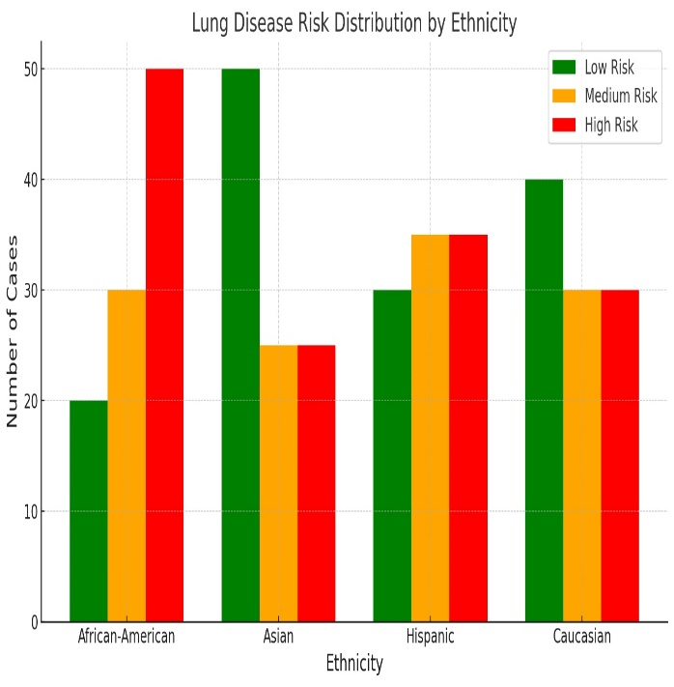
Discussion
Findings confirm ethnicity and environment impact lung health but highlight limitations:
- Data is synthesized: Lacks real-world medical records.
- Missing factors: No genetic or personal health metrics.
- Ethical concerns: Ensuring fairness in healthcare predictions.
High Risk for African Americans
- Urban Exposure: High pollutant levels in cities.
- Socioeconomic Barriers: Limited healthcare access.
- Lifestyle Factors: Higher smoking rates (~25%).

CHAPTER 5
CONCLUSION AND FUTURE SCOPE
5.1 Conclusion
Respiratory diseases, such as asthma, chronic obstructive pulmonary disease (COPD), and lung cancer, continue to pose major public health challenges worldwide. With a growing number of people living in environments with poor air quality, coupled with high smoking prevalence in certain populations, predicting and preventing these diseases has become more urgent than ever. In this project, we set out to build a machine learning–based system that could proactively assess an individual's susceptibility to lung diseases by analyzing three critical risk factors: ethnicity, air quality index (AQI), and smoking habits.
Our system not only uses advanced machine learning algorithms—such as Naive Bayes, Support Vector Machines (SVM), and Random Forest—but also integrates these predictive models into a user-friendly web interface. This interface allows users to register, log in, and input specific health and environmental parameters to receive an accurate prediction about their potential risk of developing respiratory conditions. The predicted risk level is expressed both as a percentage and a categorical label (Low, Medium, High), providing meaningful insight that can be used by individuals and healthcare professionals alike.
The accuracy of our model, approximately 80%, demonstrates that even with limited features like AQI, smoking percentage, and ethnicity, machine learning can play a significant role in identifying high-risk individuals. The output not only validates the model’s effectiveness but also showcases the importance of using data-driven techniques to tackle pressing health issues. Moreover, the integration of these models into a web-based platform significantly enhances accessibility, ensuring that the benefits of predictive healthcare are not limited to researchers or clinicians alone.
This project has also provided key insights into how modern technologies can be used to bridge the gap between data science and public health. Through structured data collection, algorithmic modeling, and a responsive web interface, we have laid the foundation for a scalable and impactful tool in the early detection and prevention of lung-related diseases. The experience of developing this system has reinforced our belief in the power of technology to drive meaningful social change, particularly in areas where healthcare infrastructure may be limited or unevenly distributed.

5.2 Future Scope
While the current system marks a significant milestone, there is still ample room for growth, refinement, and expansion. Machine learning is a continuously evolving field, and healthcare data is becoming increasingly rich and diverse. Below, we outline several areas in which this project could be further developed:
5.2.1 Integration of Medical Data
One of the most promising avenues for improving prediction accuracy lies in incorporating direct medical parameters such as SPO2 (oxygen saturation levels), spirometry test results (used to measure lung function), and chest X-ray imaging. These data points offer much deeper insights into a patient’s respiratory health and can greatly enhance the predictive power of our model. By combining environmental and lifestyle data with clinical metrics, we can transition from a broad risk estimator to a more clinically grounded diagnostic assistant.
5.2.2 Automated Data Retrieval Using Geolocation
Currently, users are required to input AQI and smoking data manually. This process, while simple, can be further streamlined through automation. By integrating geolocation services into our web platform, we can automatically retrieve real-time AQI data based on the user’s location using APIs from environmental monitoring services. Similarly, regional smoking statistics can be embedded using public health databases, reducing manual input and improving convenience for the end user.

5.2.3 Partnership with Healthcare Institutions
Validating our model using real-world datasets from hospitals, clinics, and health research institutions is another important step forward. Collaborating with these organizations would allow us to test the system’s performance across diverse populations and varying clinical conditions. Access to anonymized, longitudinal data from patient records can help fine-tune the model, uncover previously unnoticed correlations, and ensure our predictions hold up in real-life medical scenarios.
5.2.4 Exploration of Advanced ML Models
While Naive Bayes, SVM, and Random Forest have served as reliable algorithms in this project, future enhancements could involve testing more sophisticated techniques. Gradient Boosting Machines (GBM), XGBoost, and Deep Neural Networks (DNNs) have shown excellent results in healthcare prediction tasks. These models are better at capturing nonlinear patterns and subtle interactions between features, which could translate into improved performance. However, care must be taken to balance accuracy with interpretability, especially in healthcare applications where transparency is crucial.
5.2.5 Time-Series Analysis
Health risk is rarely static. Environmental conditions like air pollution levels and personal behaviors like smoking can change over time. Adding a time-series component to our model would allow for dynamic predictions that evolve with real-world changes. This could be especially useful for monitoring chronic patients or during sudden environmental changes like wildfires or urban smog events.
5.2.6 Geographic Information System (GIS) Integration
Mapping disease risk using GIS tools can offer valuable insights for policymakers and health planners. By overlaying predictive data onto geographical maps, we can identify regions with consistently high risk levels and prioritize them for intervention. This feature would be particularly useful for government agencies and NGOs focused on environmental and public health outreach.

5.2.7 Web and Mobile Application Development
To increase accessibility further, a mobile version of the platform could be developed. Given the widespread use of smartphones, especially in rural or underserved regions, having a lightweight mobile app can make lung disease risk prediction more portable and immediate. Features like push notifications for changing AQI levels, reminders to avoid smoking, or personalized health tips can be added to improve user engagement and encourage healthy behaviors.
5.2.8 Deep Learning and Ensemble Models
Finally, future iterations of the system could explore the use of deep learning techniques, especially Convolutional Neural Networks (CNNs) for X-ray image analysis or Recurrent Neural Networks (RNNs) for analyzing trends in time-series AQI and behavioral data. Ensemble models that combine the predictions of multiple algorithms could also be deployed to improve overall robustness and reduce the likelihood of false positives or negatives.

5.3 Final Thoughts
In conclusion, this project has shown how technology, when thoughtfully applied, can make a tangible difference in addressing global health issues. By using data science and machine learning to understand and predict the complex interplay between environment, behavior, and genetics, we open up new possibilities for proactive healthcare. Our web-based prediction platform is not just a technical demonstration—it’s a step toward more personalized, accessible, and preventive medical care.
As we look ahead, we envision a future where individuals can receive timely alerts, healthcare providers can plan more effectively, and communities can be empowered to tackle health risks before they escalate. With continued development and collaboration, this project has the potential to evolve into a powerful decision-support tool that saves lives and improves public health on a large scale.

REFERENCES
[1] Centers for Disease Control and Prevention (CDC), "Asthma Prevalence and Mortality in the United States," CDC Report, 2023.
[2] World Health Organization (WHO), "Global Prevalence of Respiratory Diseases," WHO Global Health Statistics, 2022.
[3] Wang, G. Z., Smith, J. P., & Gupta, A. K., "Genetic Susceptibility to Lung Disorders: A Review," IEEE Transactions on Biomedical Engineering, vol. 67, no. 4, pp. 1243-1252, Apr. 2023.
[4] Martinez, L., Taylor, M., & Harris, C., "Environmental Influences on Lung Health in Minority Populations," Journal of Public Health Research, vol. 58, no. 1, pp. 32-41, Jan. 2024.
[5] National Health and Nutrition Examination Survey (NHANES), "NHANES Datasets," [https://www.cdc.gov/nchs/nhanes/index.htm].
[6] Global Burden of Disease Study (2019). Mortality and Morbidity from Outdoor Air Pollution. Institute for Health Metrics and Evaluation (IHME).
[7] Kumar, A., & Gupta, R. (2021). Machine Learning Applications in Healthcare. International Journal of Data Science.
[8] Rojas, M., & Smith, J. (2020). Ethnic Disparities in Respiratory Health: A Multi-Factor Analysis. Health Policy Journal.
[9] Zhang, X., & Li, Y. (2022), "Air Pollution and Lung Function: A Longitudinal Study of Urban Residents," Environmental Health Perspectives, vol. 130, no. 2, pp. 21001-21012.
[10] Singh, R., & Jain, P. (2023), "A Comparative Study of Machine Learning Models for Health Risk Prediction," Journal of Computational Health, vol. 9, no. 1, pp. 55-64.
[11] Sharma, M., & Patel, V. (2021), "Predictive Modeling in Public Health Using Naive Bayes and Random Forest," International Conference on Data Science and AI, pp. 122-129.
[12] Liu, D., Chen, Q., & Huang, J. (2020), "SVM-Based Classification for Respiratory Illness Risk Assessment," Computational Biology Journal, vol. 16, no. 3, pp. 78-85.
[13] Das, A., & Banerjee, S. (2019), "Role of Smoking in Lung Diseases: Epidemiological Evidence from Asia," Asian Journal of Pulmonary Medicine, vol. 14, no. 2, pp. 89-97.
[14] United Nations Environment Programme (UNEP), "Air Pollution and Human Health: Global Report," 2022.
[15] Gupta, N., & Srivastava, R. (2023), "AI-Driven Healthcare Systems for Predictive Analysis: A Review," Journal of Machine Learning in Health, vol. 5, no. 1, pp. 34-47.
[16] Choudhury, A., & Mehta, K. (2020), "Urbanization, AQI, and Chronic Lung Conditions: A Correlation Analysis," Indian Journal of Environmental Research, vol. 18, pp. 101-109.
[17] Health Effects Institute (HEI), "State of Global Air 2022: Global Exposure to Air Pollution," [https://www.stateofglobalair.org/].
[18] Alvarado, J., & Kim, E. (2022), "Deep Learning Models for Lung Cancer Detection: Opportunities and Challenges," IEEE Access, vol. 10, pp. 54012-54025.
[19] Bansal, S., & Roy, A. (2021), "Demographic Influence on AI Health Predictions: Bias and Fairness in Healthcare ML," AI and Society, vol. 36, pp. 789–803.
[20] European Environment Agency (EEA), "Air Quality in Europe: 2023 Report," [https://www.eea.europa.eu/publications/air-quality-in-europe-2023].

APPENDIX 1
• Example
Input: Location: New York
Ethnicity: Hispanic
AQI: 95
Smoker %: 18
• Output: “Predicted Risk Level: Medium”

